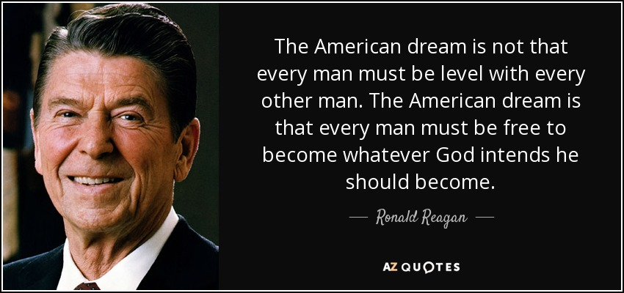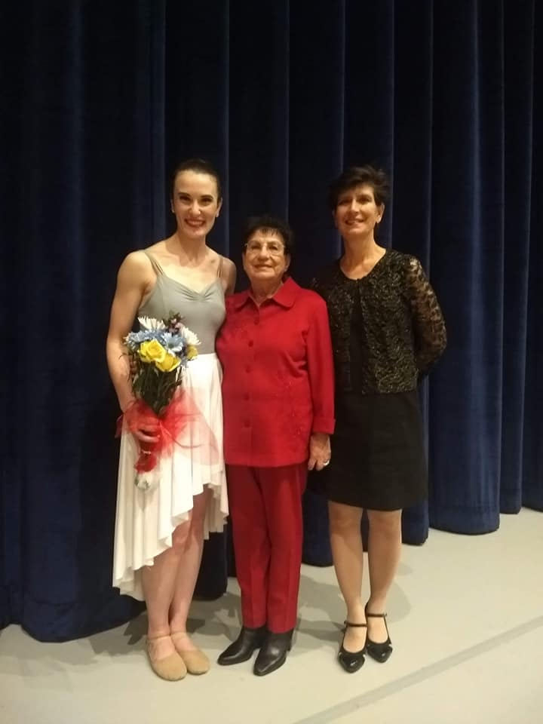

Ms. Carol, K6 [mcarol@desertviewschools.com](mailto:mcarol@desertviewschools.com)

**Dear Parents and Guardians,**

**WELCOME to Desert View Academy! I am Marian Carol. I am very pleased to be a part of this significant milestone in your child's life. I graduated from Arizona State University with a Bachelor of Science in Political Science, University of Arizona with a Juris Doctorate, and took teaching courses at University of Phoenix and Grand Canyon University. I have twelve years of teaching experience at the kindergarten level.**

**Kindergarten is an exciting and important experience for your child. Many children and parents may be anxious of this new adventure, particularly with the COVID-19 remote learning challenges. Please feel assured that my classroom is a high energy, friendly and nurturing environment and I will seek to replicate as best as possible via satellite. I will seek to ensure that your child feels included. To accomplish this, I need your support. Your involvement is the essential key to your child's success. I will send constant messages through Remind and please, likewise, contact me anytime regarding any questions or concerns through the Remind app.**

**Thank you for the opportunity to share this special year with you and your child.**

**Ms. Marian Carol**.

Meet Your Teacher